Rhetorical Analysis Assignment
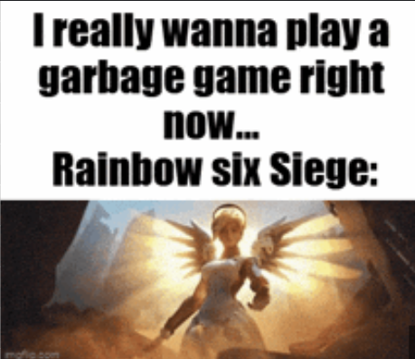

Purpose: The purpose of this meme was to make people in the gaming community laugh, specifically Rainbow 6 Siege (R6) players.
Audience: The target audience is mainly players within the R6 community, or those who have previously played the game before.
Media: A gif/image is the visual representation that is used to capture the audience’s attention. Having an image with large text makes the message easier to read and post across multiple social media platforms.
Rhetorical Analysis: What makes this meme funny is the simplicity, yet underlaying depth provided within it. While on the surface it looks like a callout to poor game mechanics, the root understanding comes from player interactions. Recently, the game as exploded in popularity again due to influencers rebounding back to it thus expanding the viewership to include both old and new users alike. One of the many complaints about R6 is the lack of solo friendly interactions when entering the ranked game mode. Those familiar with the game know the pain of dealing with teammates not listening to directions, friendly fire, match making discrepancies, and overall trolling by others. When taking all these factors into consideration, it makes the game seem frustrating or unenjoyable to some hence the “garbage” reputation put behind it. One of the lacking elements of this meme is that those who have no relation to R6 will not understand the meaning behind it and just automatically assume the game is bad without any real knowledge to back it up.

